Anchoring Phenomenon Routine for
Grade 5 - Space Systems Systems, Stars and the Solar System
The Anchoring Phenomenon Routine is the launch to student investigation around the anchoring phenomenon. This phenomenon will be the one that students will describe and explain, using disciplinary core ideas, science and engineering practices and crosscutting concepts in investigations. The Anchoring Phenomenon Routine will encourage thoughtful consideration of the phenomenon, initial models, connections to related phenomenon, discussions about the phenomenon and the creation of the KLEWS chart used for documenting student learning.
In an Anchoring Phenomenon Routine, students:
- ● Are presented with a phenomenon or design problem
- ● Write and discuss what they notice and wonder about from the initial presentation
- ● Create and compare initial models of the phenomenon or problem
- ● Identify related experiences and knowledge that they could draw upon to explain the phenomenon or solve the problem
- ● Construct a KLEWS Chart
- ● Identify potential investigations to answer the questions on the KLEWS Chart, adding the questions to the chart
What is a phenomenon?
In these Anchoring Phenomenon Routine resources, we have selected phenomena that are common for students, related to at least one Performance Expectation but preferably two or more, and can be described/explained using at-home learning.
Phenomena are experiences in the natural (science) or designed (engineering) world that encourage students to explore and explain the world around them. Excellent phenomena demand explanation.
Learn more about qualities of good anchoring phenomenon. The first criteria of anchoring phenomenon used in this brief: A good anchor builds upon everyday or family experiences: who students are, what they do, where they came from. It is important that it is compelling to students from non-dominant communities (e.g., English language learners, students from cultural groups underrepresented in STEM, etc.). We were particularly careful about selecting phenomena connected to everyday or family experiences. This should be a common goal for all anchoring phenomena, in these resources and in all science learning resources.
It is not the role of anchoring phenomena to be phenomenal. For example, in this space systems learning experience, we do not focus on crashes in space or the likelihood of large asteroids hitting earth like in a science fiction movie. These events happen but they are not in the everyday or family experiences of all students. Instead, for this experience students will focus on daily patterns they can observe by collecting data from shadows, tables and charts, and changes over the seasons by looking at the sky. These experiences are right there, at hand, for students to observe, describe, and explain.
PE Focus Bundle at NSTA.org
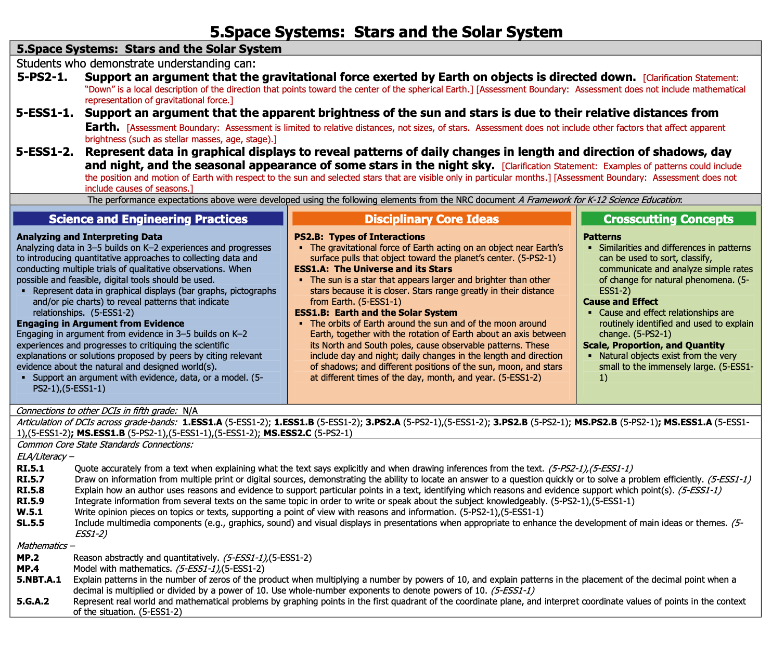

Science in Grade 5 Overview
Science learning for grade 5 students begins to focus on ideas that are less tangible than in the earlier grades - gravity and gravitational force and the distances of stars. Although some of the ideas are less central to students’ everyday experiences, the science concepts are connected to experiences and still require and demand investigations of various types to explain. Several investigations of this type are suggested at the end of the document.

In this Anchoring Phenomenon Routine, the students will make observations of shadows and use those observations to begin questioning how light, objects and surfaces connect to each other to create shadows. The questions will derive from the experience with the anchoring phenomenon and then move more broadly to explaining why these changes occur through subsequent investigations. As students investigate shadows they may include questions about the stars, about gravity, etc, that would be part of the other disciplinary core ideas in this bundle.

As part of the ongoing work, students can continue these observations over multiple days to identify the patterns in how shadows change from day to day.

What causes shadows to move and change?
What changes occur because of the earth, moon and Sun?
(Sample Driving Questions)
What do we think we KNOW? | What are we LEARNING? | What is our EVIDENCE? | What are we WONDERING? | What SCIENCE words and principles help us explain?
Example initial KLEWS chart

At home needed materials - flashlight, various objects, notebook, pencil

Synchronous Time- One hour, 40 minutes

Asynchronous Time- 35+ minutes

Present a Phenomenon - 15 minutes
There are several shadows in photography websites and resources. Search for photographs that use shadows in ways that will be interesting to your students. Using photographs is one way to incorporate the arts into the Anchoring Phenomenon Routine and to encourage students to seek out arts connected related phenomenon. Using multiple photographs will encourage students to explore various ideas about shadows and extend their wondering beyond their lived experiences.

Here are three suggestions (please remember to keep the source link with the photo when using):

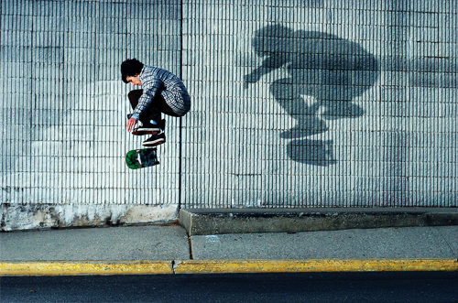  Source | 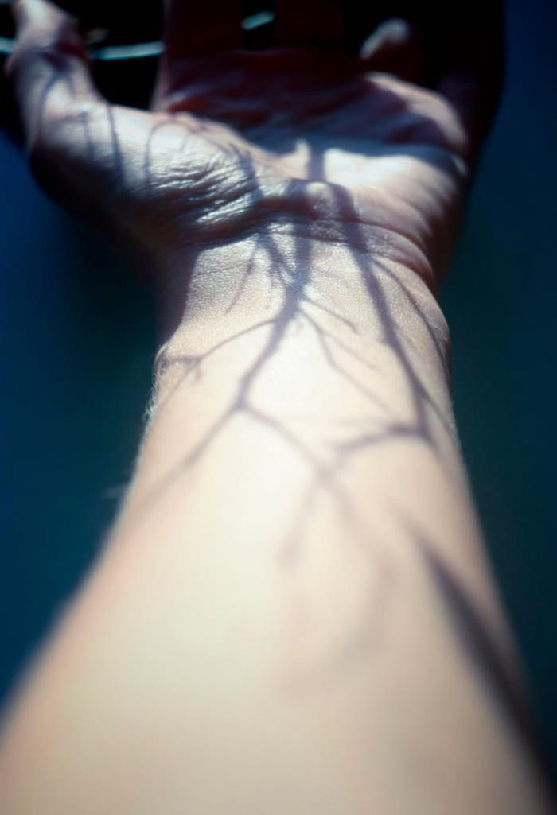source
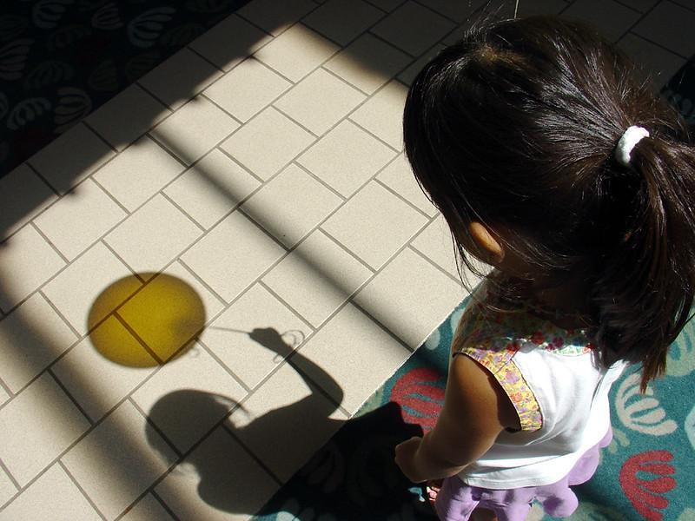 | Source

Begin creating the KLEWS Chart. Share with students the Driving Question at the top of the chart. Two options are provided, choose one or create your own. The question should focus on shadows.

Share the pictures you have chosen with the students. Each student should be able to see least one photograph. Here are some questions that you might ask the students. The goal is to use a photograph to initiate thinking about the shadows used by the photographer.

Sample Talk:
(Focus on the photograph)
What do you notice about the photograph?
How does the photograph make you feel?
How does this photograph connect to what you have done in the past?
(Beginning of focus on shadows)
Where are the shadows in the photo?
How would the photo change if the photographer had not included the shadows?
(Begin to focus on the science of shadows)
What did the photographer need to consider in order to capture the picture as it is?
What did the photographer need to get that shadow in the photo?

Notice and Wonder - 25
Adding to the KLEWS Chart, using the What do we think we KNOW and What are we WONDERING columns

Science Talk Opportunity

Potential Student Ideas that might be added to the two columns. In general, students’ noticings and current thinking (without teacher/adult editing) would be added to the KNOW column and student questions could be added to the WONDERING column.

What do we think we KNOW? | What are we WONDERING?
Pictures with shadows require light. | What made those shadows that look like veins? How did the photographer get those pictures?
Shadows in pictures are not easy to capture. | Do you always need the sun to make shadows?
The shadows add depth to the pictures | Do the shadows change depending on where the objects are? What the skateboarder moves does the
The shadows make the picture more interesting. | Why do shadows change?
The shadow should be as big as the tree (it is smaller) and the skateboarder (it is bigger). | Why are the shadows different sizes from the objects that created the shadows?
 | Do shadows move?
 | What light makes shadows, the sun? Any other lights? Do all lights make shadows?
 | Some shadows are really clear with borders that are clear and some or not. Why?
 | How come no shadows have color, they are all black or grey?

Create and Compare Initial Models - (asynchronous option) - 25 minutes

Select one of the photographs. Ask students to use this photo to think about the components that are needed to make the shadows. Refer back to the Wondering question list, and have students identify the questions that are related to the components (light, object of the shadow, surface the shadow falls on) that make the shadow. Use icons or photos to represent the components, and add descriptive words to the icons. To simply this process, you might provide a library of graphics for students to use, it is included here.

Ask students to use the graphics to individually create their initial model of how the shadows are created. Emphasize that this is the initial thinking and that they should document their thinking in pictures and words to show why shadows happen.
If possible, prior to the next meeting, ask students to observe shadows outdoors. Ask them to make observations several times during the day. If it is not possible to go outside, the students could observe an object near a window with light coming in.

Related Experiences and Knowledge - 20 minutes

To complete the Related Experiences section virtually, students can email pictures of their models, add their models to a set of slides, or share in any way that makes the models accessible to others. Prior to the discussion, assess the students’ initial models. Note critical features: the object between the light source and the surface, that light is traveling (but maybe not in straight lines, yet). Pay attention to the features and components students have used in their initial models. Focus your assessment on the relationship between the light source and the objects that create the shadow.

Students will join the discussion having searched outside for examples of shadows. Ask students to identify several shadows throughout the course of the day and make observations of them. They might create sketches of the light source, object and shadow or take pictures, like the photographs that provided the entry into the anchoring phenomenon.

Have students refer back to their initial models. Lead a discussion with the students using their models to share initial ideas of how light, objects and surfaces, work to create shadows. Ask them to add their additional, related phenomenon, observations, too.

Using the students’ initial models, ask various students to share their models. Focus any probing questions on developing the initial understanding of the ways that shadows are made.

Sample Talk:
I noticed in your initial model and your description, that you said that to make a shadow you need a light source. Show us on your model how you represented the light source and how the light moves to create the shadow.

Include time to discuss the shadows that the students found outside or that were made by sunlight. Ask them to discuss if all shadows are the same, those made with sunlight and those made with other light sources.

Adding to the KLEWS Chart WONDERING Column - 15 minutes
As students are sharing their initial models and the other shadows they found outside, listen for additional KLEWS Wondering questions and/or refer back to other questions students have already added to the KLEWS chart.

Sample Talk:
As you have been talking about the shadows you found outside and comparing them to the shadows you found inside, I am wondering if you noticed similarities and differences among ways of making shadows.

Students should recognize that there is a pattern in the systems that make shadows, they all need a light source, an object and a surface that the shadow falls on.

Add students’ ideas about related shadows, to the KNOW or WONDERINGS columns as appropriate.
What do we think we KNOW? | What are we WONDERING?
Pictures with shadows require light. | What made those shadows that look like veins? How did the photographer get those pictures?
Shadows in pictures are not easy to capture. | Do you always need the sun to make shadows?
The shadows add depth to the pictures | Do the shadows change depending on where the objects are? What the skateboarder moves does the
The shadows make the picture more interesting. | Why do shadows change?
The shadow should be as big as the tree (it is smaller) and the skateboarder (it is bigger). | Why are the shadows different sizes from the objects that created the shadows?
 | Do shadows move?
 | What light makes shadows, the sun? Any other lights? Do all lights make shadows?
 | Some shadows are really clear with borders that are clear and some or not. Why?
 | How are the shadows made by the sun different from those made by a lamp?
 | Why are all shadows not very dark black?
 | Can we learn to predict where a shadow is going to be at a certain time of day? Does the shadow at some time of the day change?

Investigations
Following the Anchoring Phenomenon Routine, students begin investigations that help them explain weather and answer some of the questions that have been added to the Wondering column. These questions will vary and the investigations might also vary. There are many ways to use the list of potential investigations with at home learning -

- Share the list of potential investigations with adults at home and ask them to support their student in completing one of the investigations.
- As students to select a Wondering that is interesting to them and will help them understand the phenomenon, provide them with the potential investigation.
- Use face-to-face or synchronous meeting times to support one or two class investigations where all students are completing the same investigation in the same way.
- If there are small group or one-to-one check-ins, have students who selected a similar investigation, share their documentation, drawings, models, and describe what they are sharing and their experiences.

The investigations rely on Fifth Grade observations and models. Adults can photograph student models or they can be created electronically and added to the class LMS (Learning Management System).

What are we WONDERING questions connected to Potential Investigations
What are we Wondering? | Potential Investigations
What made those shadows that look like veins? How did the photographer get those pictures? | Investigate shadows and how they are made using a light source. Document with photographs or drawings. Change the distance of the light from the object. Change the distance of the surface from the object.
Do you always need the sun to make shadows? | Observe the same object under different conditions, outside at the same time every day. Document the amount of sun (sky conditions) and the location of the shadows over several days.
Do the shadows change depending on where the objects are? When the skateboarder moves does the shadow move? | Using the sun and several moving objects, observe hot the shadow moves as the object moves.
Why do shadows change? | Explore how changing the light source (lamp, flashlight, sun etc) changes the shadow. Keep the object and surface the same  Explore how changing the distance of the light source changes the shadow. Keep the light and surface the same.
Why are the shadows different sizes from the objects that created the shadows? | Using a light source and measuring tools, explore the size of the shadow as the object is moved closer and farther from the light. Use one object to compare any size changes to the original shadow.
Do shadows move? | Observe the same tall object, outside, for several sunny days. Observe three times per day at the same times each day.
What light makes shadows, the sun? Any other lights? Do all lights make shadows? | Test multiple different light sources to see how the light source changes the shadow.
Some shadows are really clear with borders that are clear and some or not. Why? | Using on light source, see how moving the light changes the borders on a shadow.
How are the shadows made by the sun different from those made by a lamp? | Compare two light sources using the same objects and positions.
Why are all shadows not very dark black?
Can we learn to predict where a shadow is going to be at a certain time of day? Does the shadow at some time of the day change?

Example - End of Learning KLEWS Chart (sample)
What causes shadows to move and change?
What changes occur because of the earth, moon and Sun?
(Sample Driving Questions)
What do we think we KNOW? | What are we LEARNING? | What is our EVIDENCE? | What are we WONDERING? | What SCIENCE words and principles help us explain?
Pictures with shadows require light. |  |  | What made those shadows that look like veins? How did the photographer get those pictures? | Cloudy  Clouds  Warm  Cool  Warmer  cooler  temperature  Blow  move  Time  pattern  weather
Shadows in pictures are not easy to capture. | Any light can be used to make a shadow | In every investigation we used some sort of light and we were able to make a shadow. | Do you always need the sun to make shadows?
The shadows add depth to the pictures | As we moved the object closer to the light source the shadow got bigger. When we moved it farther away the shadow got smaller. | In the investigations with the ball, the shadow changed size as it was moved. The light stayed in the same place. | Do the shadows change depending on where the objects are? What the skateboarder moves does the
The shadows make the picture more interesting. | As the light source moves, shadows change. | Every time we move the light away from or closer to the source, the shadow changes. | Why do shadows change?
The shadow should be as big as the tree (it is smaller) and the skateboarder (it is bigger). | When the light source is closer to the object, the shadow is smaller. When the light is farther away, the shadow is bigger. | We measured the size of the object and the size of the shadow as we moved the light. Each time and with each light the measurements changed as we moved the light. | Why are the shadows different sizes from the objects that created the shadows?
 | We could make the shadows move by moving the light or by moving the object |  | Do shadows move?
 |  |  | What light makes shadows, the sun? Any other lights? Do all lights make shadows?
 |  |  | Some shadows are really clear with borders that are clear and some or not. Why?
 |  |  | How are the shadows made by the sun different from those made by a lamp?
 |  |  | Why are all shadows not very dark black?
 | The patterns of shadows made by the sun are predictable over days and seasons. | We ran some tests using the sun as the light source. Each day the shadow moved the same way, in a pattern. The length of the shadow changed too. We could use these measurements to make predictions | Can we learn to predict where a shadow is going to be at a certain time of day? Does the shadow at some time of the day change?
References:
KLEWS chart collection at NSTA - - https://my.nsta.org/collection/62205

