Anchoring Phenomenon Routine for
Grade 4 - Structure, Function, and Information Processing
The Anchoring Phenomenon Routine is the launch to student investigation around the anchoring phenomenon. This phenomenon will be the one that students will describe and explain, using disciplinary core ideas, science and engineering practices and crosscutting concepts in investigations. The Anchoring Phenomenon Routine will encourage thoughtful consideration of the phenomenon, initial models, connections to related phenomenon, discussions about the phenomenon and the creation of the KLEWS chart used for documenting student learning.
In an Anchoring Phenomenon Routine, students:
- ● Are presented with a phenomenon or design problem
- ● Write and discuss what they notice and wonder about from the initial presentation
- ● Create and compare initial models of the phenomenon or problem
- ● Identify related experiences and knowledge that they could draw upon to explain the phenomenon or solve the problem
- ● Construct a KLEWS Chart
- ● Identify potential investigations to answer the questions on the KLEWS Chart, adding the questions to the chart
What is a phenomenon?
In these Anchoring Phenomenon Routine resources, we have selected phenomena that are common for students, related to at least one Performance Expectation but preferably two or more, and can be described/explained using at-home learning.
Phenomena are experiences in the natural (science) or designed (engineering) world that encourage students to explore and explain the world around them. Excellent phenomena demand explanation.
Learn more about qualities of good anchoring phenomenon. The first criteria of anchoring phenomenon used in this brief: A good anchor builds upon everyday or family experiences: who students are, what they do, where they came from. It is important that it is compelling to students from non-dominant communities (e.g., English language learners, students from cultural groups underrepresented in STEM, etc.). We were particularly careful about selecting phenomena connected to everyday or family experiences. This should be a common goal for all anchoring phenomena, in these resources and in all science learning resources.
It is not the role of anchoring phenomena to be phenomenal. For example, in this space systems learning experience, we do not focus on crashes in space or the likelihood of large asteroids hitting earth like in a science fiction movie. These events happen but they are not in the everyday or family experiences of all students. Instead, for this experience students will focus on daily patterns they can observe by collecting data from shadows, tables and charts, and changes over the seasons by looking at the sky. These experiences are right there, at hand, for students to observe, describe, and explain.
PE Focus Bundle at NSTA.org 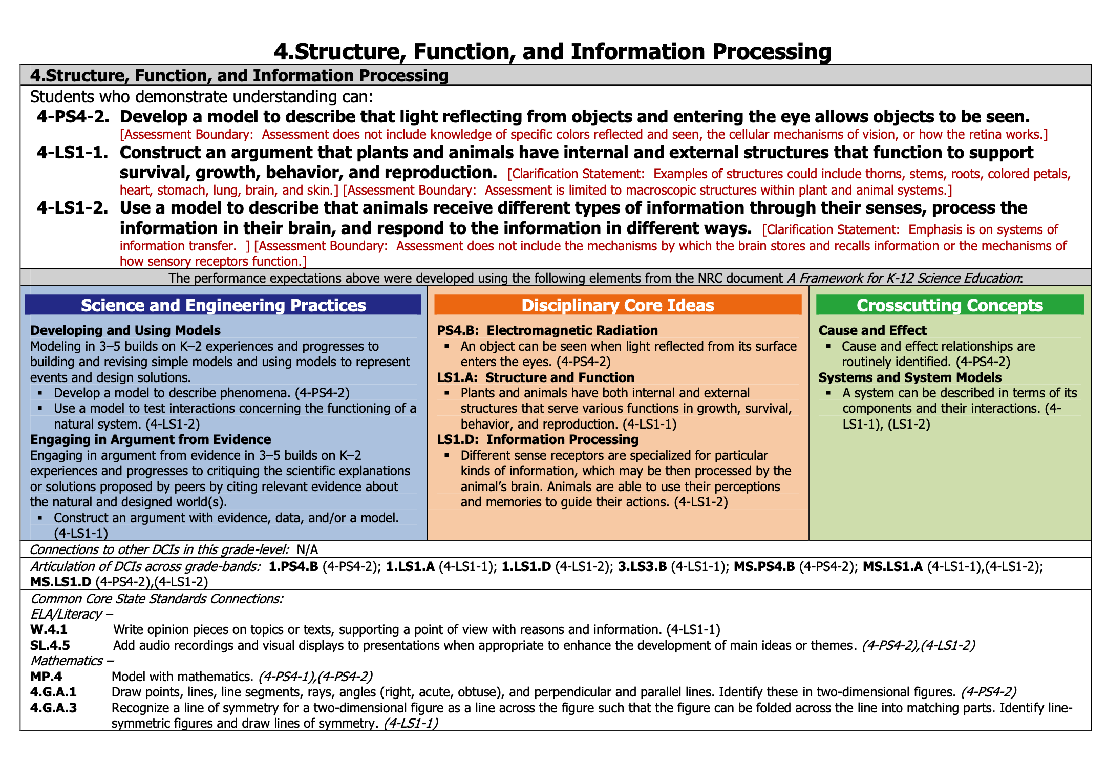

Science in Grade 4 Overview
Science learning for grade 4 students builds on previous life science foci. Transitioning to more abstract concepts and the use of modeling to explain ideas is a big part of grade 4 science.

In this Anchoring Phenomenon Routine, the students will extend their understanding of senses to include other animals, the role of the brain, and responses to stimuli. Learning about and using their understanding of the senses is different from a more traditional focus of testing of the senses. In this work, students will create a more sophisticated connection between the senses, the brain and responses guiding behavior. They also are positioned to make this connection with many animals, finding and using patterns that exist across species. All animals use the external features that are their sense organs to collect information about their world and react to it.

To create opportunities for students to do this work in a remote/hybrid environment some they will be able to make observations about their own behavior as well as that of a pet, animals they can observe outdoors, or even animals they might find on videos.

How do animals respond to things they sense?
(Sample Driving Question)
What do we think we KNOW? | What are we LEARNING? | What is our EVIDENCE? | What are we WONDERING? | What SCIENCE words and principles help us explain?
Example initial KLEWS chart

At home needed materials - notebook, pencil, and a camera (optional)

Synchronous Time- One hour over several meetings

Asynchronous Time- 35 minutes

Present a Phenomenon -
The anchoring phenomenon routine begins by having students notice that they have a reaction to their favorite foods/meal. They will use this experience to create a list of related times when they use their senses and then respond to the stimulus.

Sample Talk
Think about the last time you ate your favorite meal. What is it? Who made it? Think about how you recognized that you were about to eat your favorite meal. Did you see the food first or smell it? When you first noticed the meal, how did you respond?

Create and Compare Initial Models - Synchronous or Asynchronous
Ask students to document the experience of their favorite meal. Ask them to draw a picture and then document with descriptive text, how they knew what the meal was going to be and how they reacted. Encourage them to document the senses that they used to notice the meal. Did they see it or the ingredients, first or maybe they smelled the meal as it was cooking?

If students are completing this section asynchronously, students can email pictures of their models, add their models to a set of slides, or share in any way that makes the models accessible to others.

Have students share their drawings with each other in small groups or with someone in their home. Sharing in a large group synchronous discussion, using remote learning tools, can be supported through sentence stems.

I recognized my favorite meal when I _____________________. When that happened my body ___________________________.

Provide students an example of how they can share their experiences. Show them how to use the sentence stem through modeling the talk.

Sample Talk
Since you have already shared your drawing with someone else, you don’t have to share the whole drawing with our group - you can focus on sharing your experiences. It might help to use the sentence stems here.

I recognized my favorite meal when I _____________________. When that happened my body ___________________________.

So I might say, I recognized my favorite meal when I smelled the soup after school. When that happened, my mouth started to water and I got really excited.

Ask each student to share their reaction, using the sentence stems. As students share, ask them to include the sense they used to first know about their favorite meal and if they had a reaction to sensing it.

Then begin creating the KLEWS Chart. Share with students the chosen Driving Question at the top of the chart. The question should focus on senses and reactions.

Notice and Wonder -
Adding to the KLEWS Chart, using the What do we think we KNOW and What are we WONDERING columns

After students have shared their ideas, begin to add students’ ideas to the KLEWS chart, Know and Wondering columns.

Science Talk Opportunity
Now that all the students have shared their ideas, ask them to notice patterns within all the responses and reactions. Students should be encouraged to evaluate the responses and document the patterns in the What do we think we KNOW column. For example, students might say that they know that sometimes when you see something, you have a reaction connected to it. This happens when you smell something, too. This should generate the ideas or suggestions that this might happen to other animals, too.

Encourage students to respond to each other’s ideas and to reflect on similarities in experiences, such as many people have reactions when they smell something that they like.

Potential Student Ideas that might be added to the two columns. In general, students’ noticings and current thinking (without teacher/adult editing) would be added to the KNOW column and student questions could be added to the WONDERING column.

What do we think we KNOW? | What are we WONDERING?
When we smell certain smells (foods) we have a reaction. | Do people smell the same things the same way?
People have different reactions, some people have watery mouths, some people get really excited, some people feel hungrier. | Why is what you love different from what I love?
We react when we smell things but also when we see things that are important to us. | Why does your brain link good food to good feelings?
Our reactions come after we sense something | Why does the smell or vision of good food make our mouths water?
Positive reactions, like feeling hungry or having our mouths water are possible. | What other reactions do we have to seeing or smelling things?
People’s reactions vary. Something that some people react to can be different from what others react to. What I like might be different from what you like. | We know we react when we recognize our favorite meal but do we react when we sense other things?
Most of the time, the things we see don’t give us a strong reaction. | Do we react to other smells that aren’t food?

Related Experiences and Knowledge -

Students might have included some related experiences or wonderings in the KLEWS chart, already. These can be used to start a discussion of related Experiences and Knowledge.

Sample Talk:
I noticed in our discussion of What do we think we Know and What are we Wondering that you mentioned many different ideas about how our senses help us notice what is happening around us. We started by talking about our favorite meals. But then we heard some observations that we have reactions when we smell bad smells too - like a skunk or spoiled food. What other ideas do you have about how your senses help you to notice your world. Do others have the same experiences?

Provide students with the document Senses and Reactions. Encourage students to pick just one or two of the list senses and reactions. Ask them to write and draw their reactions to their selected experience.Then they should interview two or three other people about how they react to different experiences.

It is important that students start to draw how they think senses are experienced and then how their brain creates a response.

After students write and draw about their experiences and complete their interviews, have them share what they learned from others. Use some talk strategies to have students share their ideas about the related experiences and then add additional Know and Wondering ideas to the KLEWS chart. Some sample ideas have been added to the KLEWS chart below to help as you lead the discussion.

What do we think we KNOW? | What are we WONDERING?
When we smell certain smells (foods) we have a reaction. | Do people smell the same things the same way?
People have different reactions, some people have watery mouths, some people get really excited, some people feel hungrier. | Why is what you love different from what I love?
We react when we smell things but also when we see things that are important to us. | Why does your brain link good food to good feelings?
Our reactions come after we sense something | Why does the smell or vision of good food make our mouths water?
Positive reactions, like feeling hungry or having our mouths water are possible. | What other reactions do we have to seeing or smelling things?
People’s reactions vary. Something that some people react to can be different from what others react to. What I like might be different from what you like. | We know we react when we recognize our favorite meal but do we react when we sense other things?
Most of the time, the things we see don’t give us a strong reaction. | Do we react to other smells that aren’t food?
 | Do all animals have reactions like we do?
 | Do other animals have senses?
 | They can see and hear, what other senses do other animals have?
 | Do pets like it when they are petted?
 | How kinds of reactions do other animals have to their senses?
 | How are other animals' reactions different or the same as ours?
 | How are the senses of different animals like those of people?
 | How do the senses of different animals help them react to their environment?

Investigations
Following the Anchoring Phenomenon Routine, students begin investigations that help them explain how senses are used to respond to the environment and answer some of the questions that have been added to the Wondering column. These questions will vary and the investigations might also vary. There are many ways to use the list of potential investigations with at home learning -

- Share the list of potential investigations with adults at home and ask them to support their student in completing one of the investigations.
- As students to select a Wondering that is interesting to them and will help them understand the phenomenon, provide them with the potential investigation.
- Use face-to-face or synchronous meeting times to support one or two class investigations where all students are completing the same investigation in the same way.
- If there are small group or one-to-one check-ins, have students who selected a similar investigation, share their documentation, drawings, models, and describe what they are sharing and their experiences.

The investigations rely on Third Grade observations, models and data analysis of daily and yearly weather data. Adults can photograph student models, copy data charts and graphs and add them to the class LMS (Learning Management System) electronically. Discussions of the models and data could also happen over the phone. If you can’t see the students’ models, ask questions about how they represented the weather data and listen carefully for their documentation and identification of possible patterns or trends in data.

What are we WONDERING questions connected to Potential Investigations
What are we Wondering? | Potential Investigations
Do people smell the same things the same way? | Interview people about what smells they like and what they do not like? See if there are more similarities or differences.
Why is what you love different from what I love? | Create a list of the foods or smells you love and compare it to others’ lists.
Why does your brain link good food to good feelings? | Read more about how the brain is connected to your senses.
Why does the smell or vision of good food make our mouths water? | Read about reactions to different foods or smells. Read about these same reactions in different animals.
What other reactions do we have to seeing or smelling things?
We know we react when we recognize our favorite meal but do we react when we sense other things?
Do we react to other smells that aren’t food?
Do all animals have reactions like we do?
Do other animals have senses? | Select one animal and observe the ways the animal reacts to their environment.  Observe a pet or animal outside your house. How does the animal react to the environment? How does the animal gather information through the senses?
They can see and hear, what other senses do other animals have? | Observe and read about the eyes, noses, or other senses of different animals. For example, do all insects sense their environment in the same way? All marine or aquatic animals?
Do pets like it when they are petted?
How do the senses of different animals help them react to their environment? | Select one animal and observe the ways the animal reacts to their environment.  Observe a pet or animal outside your house. How does the animal react to the environment? How does the animal gather information through the senses?

Example - End of Learning KLEWS Chart (sample)
What causes shadows to move and change?
What changes occur because of the earth, moon and Sun?
(Sample Driving Questions)
What do we think we KNOW? | What are we LEARNING? | What is our EVIDENCE? | What are we WONDERING? | What SCIENCE words and principles help us explain?
When we smell certain smells (foods) we have a reaction. | When people smell food, their mouths water and they have other reactions | We gathered survey data and most people have this reaction to certain foods, particularly food they love. | Do people smell the same things the same way? | Smell  Feel  See  Light  Brain  Reaction  React  Response
People have different reactions, some people have watery mouths, some people get really excited, some people feel hungrier. | When people smell food, their mouths water and they have other reactions | We gathered survey data and most people have this reaction to certain foods, particularly food they love. | Why is what you love different from what I love?
We react when we smell things but also when we see things that are important to us. |  |  | Why does your brain link good food to good feelings?
Our reactions come after we sense something | People’s mouths water, and they have other reactions but only after they sense something. | No one we interviewed actually had a reaction BEFORE they sensed something. | Why does the smell or vision of good food make our mouths water?
Positive reactions, like feeling hungry or having our mouths water are possible. |  |  | What other reactions do we have to seeing or smelling things?
People’s reactions vary. Something that some people react to can be different from what others react to. What I like might be different from what you like. | Not everyone had the same reactions | When we did our research we learned that not everyone had the same reaction to the same stimulus. | We know we react when we recognize our favorite meal but do we react when we sense other things?
Most of the time, the things we see don’t give us a strong reaction. | Just because we see something or smell something doesn’t mean that we will react strongly | Memories don’t connect that way for a lot of things we smell or see or sense. | Do we react to other smells that aren’t food?
When we smell certain smells (foods) we have a reaction. |  |  | Do all animals have reactions like we do?
People have different reactions, some people have watery mouths, some people get really excited, some people feel hungrier. |  |  | Do other animals have senses?
We react when we smell things but also when we see things that are important to us. | When we smell and see things the smell and sight are processed in our brains. | We read about this part, our eyes and noses are connected to our brains. The information is processed in our brains. | They can see and hear, what other senses do other animals have?
Our reactions come after we sense something | We see something then we react to it or we smell something and then we react to it | Our memories help us in the reaction but the reaction is always following the actual sight or smell. | Do pets like it when they are petted?
Positive reactions, like feeling hungry or having our mouths water are possible. | When we sense something we like, we have a positive reaction | When each had things that made us have a positive reaction. The reaction happened after we sensed something. | How do the senses of different animals help them react to their environment?

References:
KLEWS chart collection at NSTA - - https://my.nsta.org/collection/62205

