Anchoring Phenomenon Routine for
First Grade Space Systems: Patterns and Cycles

The Anchoring Phenomenon Routine is the launch to student investigation around the anchoring phenomenon. This phenomenon will be the one that students will describe and explain, using disciplinary core ideas, science and engineering practices and crosscutting concepts in investigations. The Anchoring Phenomenon Routine will encourage thoughtful consideration of the phenomenon, initial models, connections to related phenomenon, discussions about the phenomenon and the creation of the KLEWS chart used for documenting student learning.
In an Anchoring Phenomenon Routine, students:
- Are presented with a phenomenon or design problem
- Write and discuss what they notice and wonder about from the initial presentation
- Create and compare initial models of the phenomenon or problem
- Identify related experiences and knowledge that they could draw upon to explain the phenomenon or solve the problem
- Construct a KLEWS Chart
- Identify potential investigations to answer the questions on the KLEWS Chart, adding the questions to the chart
What is a phenomenon?
In these Anchoring Phenomenon Routine resources, we have selected phenomena that are common for students, related to at least one Performance Expectation but preferably two or more, and can be described/explained using at-home learning.
Phenomena are experiences in the natural (science) or designed (engineering) world that encourage students to explore and explain the world around them. Excellent phenomena demand explanation.
Learn more about qualities of good anchoring phenomenon. The first criteria of anchoring phenomenon used in this brief: A good anchor builds upon everyday or family experiences: who students are, what they do, where they came from. It is important that it is compelling to students from non-dominant communities (e.g., English language learners, students from cultural groups underrepresented in STEM, etc.). We were particularly careful about selecting phenomena connected to everyday or family experiences. This should be a common goal for all anchoring phenomena, in these resources and in all science learning resources.
It is not the role of anchoring phenomena to be phenomenal. For example, in this space science learning experience we did not choose an event like an eclipse or meteor showers. These events happen, but they are not in the everyday or family experiences of all students. Students can look out a window, walk outdoors, and use their senses to observe, describe, and explain the day or night sky. This makes everyday observations and the patterns the students can observe and document, a perfect phenomenon.

PE Focus Bundle at NSTA.org
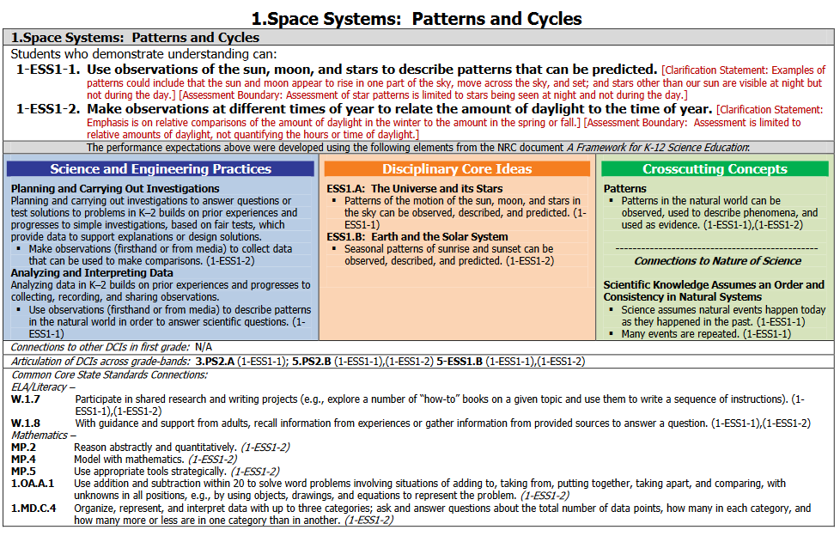

Overview
Science learning for First Grade students focuses on observations, data collection and analysis for finding patterns over time and sharing ideas with others.

In this Anchoring Phenomenon Routine, the students will make observations of the daytime sky and the nighttime sky from their home, draw pictures of the objects in the sky at various times of the day/night (creating a model/artifact of their observations), and looking for predictable patterns. They will identify their own questions about the apparent movements of the sun, the moon, and the stars and add those questions to the KLEWS chart.

As part of the ongoing work, then, students can continue these observations over multiple days to identify (with support) the patterns of the day and nighttime objects in the sky. In making these simple and easily accessible observations of the sky, students are planning and carrying out investigations.

Does the sun move the same way every day? (Sample question)
What other patterns can we find in the sky?
What do we think we KNOW? | What are we LEARNING? | What is our EVIDENCE? | What are we WONDERING? | What SCIENCE words and principles help us explain?
Example initial KLEWS chart

At home materials - notebook or paper, drawing tools

Synchronous Time- 55 minutes

Present a Phenomenon - 5 minutes
Begin by sharing with students your observations of the sun this morning (or a morning when the sun was shining). In telling your observations include details about darkness, dawn, sunrise, and positions of the sun. See bold text in sample talk below for connections to these words.

Sample Talk: This morning when I woke up it was dark outside. I looked out my window to look for the moon, but I could not see the moon. I knew it wasn’t time for me to get up, because I usually wait to get up until it is light and I can see some of the things in my bedroom. I stayed in bed until I noticed that I could begin to see the lamp next to my bed and the chair by the window. I could hear the birds chirping outside my window. I looked out my window. I couldn’t see the sun, but the sky was getting brighter. After a few minutes, I looked out my window again, and I could see beautiful colors in the sky as the bright sun was beginning to show above the trees outside. I had never really noticed that I could see the sun outside my bedroom window. I wasn’t sure if that happened every day. After I ate breakfast, I went to my bedroom to get dressed. I looked out my window to see if I could still see the sun. I noticed that it was much higher in the sky. I wondered if the sun always moves the same way every day.

Begin creating the KLEWS Chart. Share with students the Driving Question at the top of the chart. Share that the class is going to really think about the movements of the sun and the moon and how they change throughout the day or night.

Notice and Wonder - 15 minutes
Adding to the KLEWS Chart, using the What do we think we KNOW and What are we WONDERING columns

Science Talk Opportunity
Ask students to comment/respond on your story. They might share their own stories about changes daylight hours, bedtimes, school start or end times, etc.

Encourage this science discussion by focusing on a few questions: What ideas do you have about the sun and how it moves? Have you ever noticed that the amount of daylight changes? When did you notice that?

Use the Talk Moves linked above to encourage students to refer to others ideas as they talk. Use revoicing and questions to help students include sun, rise, dawn, movement, night, day into their comments.

During this discussion begin to add student’s ideas to the What do we think we KNOW and What are we WONDERING columns. Use these columns flexibly to document students’ ideas.

Potential Student Ideas that might be added to the two columns. In general, students’ noticings and current thinking (without teacher/adult editing) would be added to the KNOW column and student questions could be added to the WONDERING column.

What do we think we KNOW? | What are we WONDERING?
The sun is not in the sky at night. | Where is the sun at night?
The moon is in the sky at night. | Are the sun and moon ever in the sky at the same time?
The sun makes the sky light. | What is the sun made of?
The sun rises. | Does the sun move? How does the sun move?
The sun moves across the sky. | How long does it take for the sun to move?
The moon looks different every night. | Does the moon change its shape?
The moon can be seen in the daytime.
Potential student Responses for KLEWS columns

Create and Compare Initial Models - 15 minutes
Have students find a place they can observe the sun and the moon each day. They can look out a window or step outside. Observations of the sky are better, if students can be outdoors.

Caution: Never look directly at the sun. Before every outdoor observation, alert students of the dangers of looking directly at the Sun in the sky. They should NEVER look directly at the Sun because it can harm their eyes! Encourage them to close their eyes and use their sense of touch by facing the Sun and feeling the Sun’s warmth on their faces—they can feel the difference in where they are facing in the morning and at noon. (pbslearningmedia.org) Or as the adult, you can help guide their observation.

Observations should be made for a minimum of three days/nights. Make daytime observations at the same times (8:00 AM, 11:00 AM, 2:00 PM, 5:00 PM, 8:00 PM) and from the same location, facing the same direction each day. Nighttime observations should be made at the same times (7:00 PM and 9:00 PM, depending on the season) from the same location each night. A set of graphics is provided so you can support students’ observations by giving them a graphic to mark on or encourage them to create their own drawings. *Note: You may choose to create a moon cycle calendar, where the shape of the moon is observed for one cycle or about 30 days. The goal is to notice changes in the sun’s location and the moon’s location/shape.

When students have completed their observations for three days - lead the drawing of a picture (this will be a First Grade-level model that describes the phenomenon of patterns of changes in the sun’s position in the sky and the moon’s position and shape) that represents the daytime and nighttime sky as students describe it. Create two graphics, one for daytime observations and one for night time. This might happen in two different class meetings.

As you are creating these initial models, help students identify the changes in position of the sun/moon and include these in your drawing. Talk out loud about how you are documenting what the students are sharing. Identify any symbols, markings, words that you use and explain why you are using them.

This initial model is one way that students might represent predictable patterns going forward. This initial, class-created, drawing should be shared with the students electronically or copies could be mailed.

Related Experiences and Knowledge - 10 minutes
Discussion of related experiences might have already happened in a previous discussion, when students discuss various daytime or nighttime stories - for example, they might have already shared stories of seeing a full moon, watching a sunset, etc.. While acknowledging students’ experiences, the goal is not to relate or delve deeply into the incredible stories of sky events but to continue to focus on predictable patterns over time.

Remind students of your story from the introduction to the phenomenon. Discuss how your story might have been the same or different from yesterday. The goal is to start building the idea of patterns or objects in the sky and/or moon shape changing. Alternatively, ask students to observe the initial model again and compare it to the pattern of the sun today or what the moon might look like tonight. However you are able, the goal is to help students observe day over day patterns of objects in the sky.

Sample Talk:
I was surprised that the sun rose right outside my bedroom window again this morning.
I thought it was interesting that the moon looked like it had grown when I saw it last night. It almost looks like a full moon.

Include time to discuss students’ ideas about how the sun seems to move across the sky. It is important to discuss that some days, we may not see the sun (Kindergarten Weather). Share ideas about the moon. Talk about whether the moon changes its position in the sky each night. Students may already notice a pattern in how the moon seems to change its shape each night (It gets bigger/smaller/disappears). Compare their initial drawings (if using the asynchronous option above) to the initial model drawing.

Adding to the KLEWS Chart WONDERING Column - 10 minutes
Ask students to share questions they have about the sun and the moon. Previously, students’ questions might have been part of the discussion. This is a more formal opportunity to generate and document additional student questions. Use the talk moves, to help students ask questions, refer to the questions that are already listed to help generate more. Encourage students to add questions about dawn, dusk, apparent movement, moon phases, to the Wondering column. If you notice that any of these ideas are missing from the questions, note that and ask students if they have questions related to that idea.

Sample Talk:
When I read through (read the questions again) all the questions you have shared here, I notice that we haven’t asked any questions about (dawn, dusk, sunrise, sunset, moon shape patterns). We drew our model and we included (insert the idea here) by drawing and labeling. So, it seems like it would be important to add questions about it to the Wondering column. What questions do you have about that idea?

Add students’ ideas about related phenomenon/other weather events, to the KNOW or WONDERINGS columns as appropriate.
What do we think we KNOW? | What are we WONDERING?
The sun is not in the sky at night. | Where is the sun at night?
The moon is in the sky at night. | Are the sun and moon ever in the sky at the same time?
The sun makes the sky light. | What is the sun made of?
The sun rises. | Does the sun move? How does the sun move?
The sun moves across the sky. | How long does it take for the sun to move?
The moon looks different every night. | How does the moon get big and small?
 | Does the sun come up at the same time every day?
 | Where does the sun go when it sets?
 | How does the moon change shape?
 | Does the moon move across the sky like the sun?
Potential student Responses for KLEWS columns

Investigations
Following the Anchoring Phenomenon Routine, students begin investigations that help them explain the movement and patterns of daytime and nighttime objects in the sky and answer some of the questions that have been added to the Wondering column. These questions will vary and the investigations might also vary. There are many ways to use the list of potential investigations with at home learning -

- Share the list of potential investigations with adults at home and ask them to support their student in completing one of the investigations.
- As students to select a Wondering that is interesting to them, provide them with the potential investigation.
- Use face-to-face or synchronous meeting times to support one or two class investigations where all students are completing the same investigation in the same way.
- If there are small group or one-to-one check-ins, have students who selected a similar investigation, share their documentation, drawings, models, and describe what they are sharing and their experiences.

The investigations rely on First Grade observations and models of predictable patterns over time. Adults can photograph these models and add them to the class LMS (Learning Management System) electronically. Discussions of the models could also happen over the phone. If you can’t see the students’ models, ask questions about how they represented the sun/moon ideas and listen carefully for documentation and identification of patterns over time.

What are we WONDERING questions connected to Potential Investigations
What are we Wondering? | Potential Investigations
Where is the sun at night? | Using a ball (or a person) and a lamp without a shade, model the rotation of the Earth on its axis. Turn counterclockwise slowly to create dawn (left arm facing lamp), noon (body facing lamp), dusk and night.  Support learning by reading day/night books.
Where is the moon during the day? | Using prior knowledge, create a model of the pattern of the moon during night and day.
How long does it take the sun to move across the sky? | Using a chart, document sunrise and sunset over 5 or more days. Look for predictable patterns.
Does the sun rise and set at the same time every day? | Using a chart, document sunrise and sunset over 5 or more days. Look for predictable patterns.
Does the moon change its shape every night? | Draw pictures of the moon over 5 or up to 30 days. Remind students to include details and labels as shown in the initial model. Look for patterns. Look at moon calendars.
Does the moon move across the sky like the sun? | Make hourly observations of the moon. Draw the moon in the sky in relation to a stationary object (i.e. tree, rooftop). View the “movement” of the moon over several nights. Does it follow the same pattern as the sun? Support learning by reading day/night books.
Potential student Responses for KLEWS columns

In subsequent face to face meetings, have students share their models, organize them to show predictable patterns over time. Discuss patterns that occur in their models. For example, notice that the sun rises in the same place every morning, it sets in the same place every night, the time of sunrise/sunset change every day, the moon changes its shape and its location in the sky every night. In face to face meetings it would also be appropriate to share with students moon calendars, sunrise/sunset chart and the ways professionals document the day and nighttime events.

Example - End of Learning KLEWS Chart
Do the sun and moon move the same way everyday? (Sample question)
What do we think we KNOW? | What are we LEARNING? | What is our EVIDENCE? | What are we WONDERING? | What SCIENCE words and principles help us explain?
The sun shines during the day. | The sun rises and sets every day.  → | We recorded the times that the sun rises (it gets light) and sets (it gets dark).  → | Is sunrise and sunset the same all year? | Sunrise  Sunset  Dawn  Dusk  Light  Dark  Rotate
The sun seems to move across the sky. | The sun rises in one place (east) and sets in the opposite direction (west). It looks like the sun moves; it is the Earth that is moving,  → | We created a model with a ball and light to show how the Earth turns (rotates) so one half of the Earth is dark and one half is light.  → | How often does the Earth turn?
The moon seems to move across the sky but not exactly like the sun. | The sun rises and sets in a predictable pattern. The moon rises and sets but the pattern is not like the sun.  → | We created a chart and recorded the times of sunrise and sunset for 5 days. We also used sunrise/sunset information from the television/computer. We created a chart and recorded the times of moonrise and moonset. We noticed that the moon’s pattern was very different than the sun’s.  → | Why are sunrise/sunset different than moonrise/ moonset?
The moon changes its shape every night. | The moon doesn’t actually change shape. It moves in different parts of the sky each night (but in the same direction). We see the part of the moon that is lit up by the sun.  → | Over the course of a month we observed the moon’s shape each night. We created a moon calendar. On nights when we couldn’t see the moon, we looked at the weather reports or a moon calendar to find out what the moon looked like on a particular night. We noticed that the moon follows a pattern that takes about a month to complete.  → | Does the moon look the same all over the world?
The sun is lighting up the other side of the Earth during the night. The moon is mostly facing the other side of the Earth during the day. | The Earth turns on its axis one time each day. When we (our town) is facing the sun, it is day. As the Earth turns it becomes darker until it is night. We see the moon at night.  → | We looked at our sunrise/sunset and moonrise/moonset charts to find a pattern. We did an activity where we used a lamp as the sun. We used our bodies as the Earth. We turned around toward our left shoulder and made sunrise, daytime, sunset, nighttime.  → | Are sunrise and sunset the same all over the world?
Potential student Responses for KLEWS columns

References:
KLEWS chart collection at NSTA - - https://my.nsta.org/collection/62205

