Anchoring Phenomenon Routine for
Third Grade Weather and Climate

The Anchoring Phenomenon Routine is the launch to student investigation around the anchoring phenomenon. This phenomenon will be the one that students will describe and explain, using disciplinary core ideas, science and engineering practices and crosscutting concepts in investigations. The Anchoring Phenomenon Routine will encourage thoughtful consideration of the phenomenon, initial models, connections to related phenomenon, discussions about the phenomenon and the creation of the KLEWS chart used for documenting student learning.

In an Anchoring Phenomenon Routine, students:
- Are presented with a phenomenon or design problem
- Write and discuss what they notice and wonder about from the initial presentation
- Create and compare initial models of the phenomenon or problem
- Identify related experiences and knowledge that they could draw upon to explain the phenomenon or solve the problem
- Construct a KLEWS Chart
- Identify potential investigations to answer the questions on the KLEWS Chart, adding the questions to the chart
What is a phenomenon?
In these Anchoring Phenomenon Routine resources, we have selected phenomena that are common for students, related to at least one Performance Expectation but preferably two or more, and can be described/explained using at-home learning.
Phenomena are experiences in the natural (science) or designed (engineering) world that encourage students to explore and explain the world around them. Excellent phenomena demand explanation.
Learn more about qualities of good anchoring phenomenon. The first criteria of anchoring phenomenon used in this brief: A good anchor builds upon everyday or family experiences: who students are, what they do, where they came from. It is important that it is compelling to students from non-dominant communities (e.g., English language learners, students from cultural groups underrepresented in STEM, etc.). We were particularly careful about selecting phenomena connected to everyday or family experiences. This should be a common goal for all anchoring phenomena, in these resources and in all science learning resources.
It is not the role of anchoring phenomena to be phenomenal. For example, in this weather science learning experience we did not choose an event like a hurricane or a tsunami. These events happen, but they are not in the everyday or family experiences of all students. Students can look out a window, walk outdoors, and use their senses to observe, describe, and explain the weather conditions found during a particular season. This makes everyday observations as well as the causes and the patterns the students can observe, document and then make predictions about, a perfect phenomenon. Through the use of weather data, students expand knowledge of weather to different seasons within the region.

PE Focus Bundle at NSTA.org
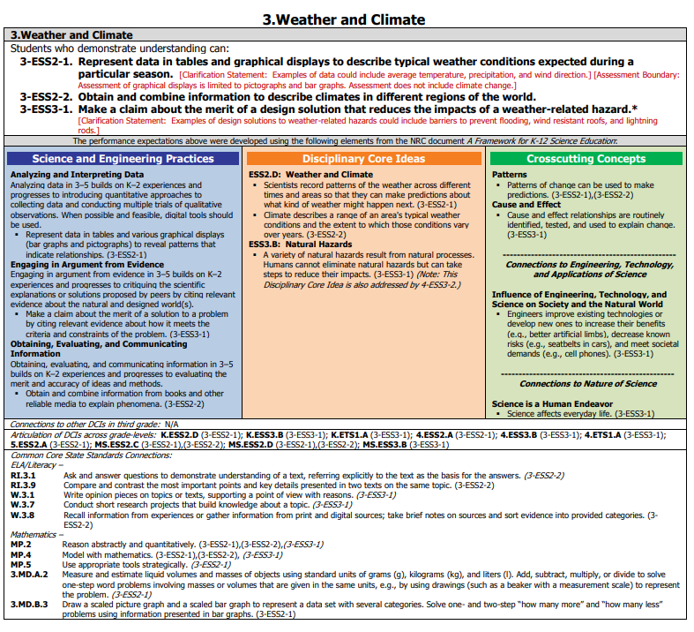

Science in Grade 3 Overview
Science learning for Third Grade students focuses on observations, data collection, plus the analysis and the interpretation of data in order to recognize weather patterns. During this process, students will be communicating ideas and information with others.

In this Anchoring Phenomenon Routine, the students will build on their understanding of weather from previous learning and personal experiences. They will make observations of minute-to-minute and daily weather patterns as well as collect and analyze local weather reports and local weather data. Students will interpret data and look for predictable patterns in seasonal data. They will identify their own questions about local weather conditions and weather patterns and add those questions to the KLEWS chart.

As part of the ongoing work, students could continue these observations over weeks and months. To do this work in a remote/hybrid environment, students will make direct observations of the daily local weather over several days. Sample local weather data will be provided so that learners will be able to document seasonal patterns and trends. Others, with access to the internet and electronic devices, will research data collected by weather scientists. Analyzing patterns in weather conditions over a year’s time will provide evidence of predictable patterns of seasonal changes and make predictions about the type of weather that will come next. In making these simple and easily accessible observations of weather conditions and trends, students are acting like weather scientists as they analyze and interpret data as well as support their ideas with evidence from their investigations.

How does the weather and climate affect our choices?
(Sample question)
What do we think we KNOW? | What are we LEARNING? | What is our EVIDENCE? | What are we WONDERING? | What SCIENCE words and principles help us explain?
Example initial KLEWS chart

At home needed materials - paper and drawing materials, weather maps or online weather resources might be used for investigations

Asynchronous Time - 25 (option)

Synchronous Time- 65 minutes

Present a Phenomenon - 5 minutes

The presenting the phenomenon is intended to connect the effect of weather on every day life and climate in the season. It does not matter what season you are starting this - it will work for every season. It could also be repeated in any season with the same or another article of clothing and the appropriate seasonal climate data.

Start by collecting some “weather” data using an article of clothing students would wear. Ask students to get the shoe (could be a jacket, etc) they would wear outside today. Have each student show the shoe they would wear and write the name of the type of shoe on a google doc or Jamboard post-it (sandal, slipper, tennis, etc). With this collected data, we start the discussion about weather.

Sample Questions:
What are some of the patterns you see in the data we have collected? Why do you suppose more people wear (select one type of shoe) than (select the other type of shoe)? Why did you select the type of shoe you did? How does your choice of clothing change based on the weather of the season or the day? What information did you use to make that decision? How did you get the information that helped you make those choices? How do you usually get that information?

Begin creating the KLEWS Chart. Share with students the Driving Question at the top of the chart. Focus students on the question and point out that we are going to consider the connections between choices, in clothing and other parts of life, and the weather/climate where we live.

Notice and Wonder - 15 minutes
Adding to the KLEWS Chart, using the What do we think we KNOW and What are we WONDERING columns

Science Talk Opportunity
Extend the previous conversation and ask students to begin crafting their What do we think we Know statements and What are we wondering? questions. You can return to these columns as students build their initial models.

Use the Talk Moves linked above to encourage students to refer to others ideas as they talk. Use revoicing and questions to help students include words such as weather, forecast, patterns, precipitation, temperature, wind direction, and seasons in their comments.

During this discussion begin to add student’s ideas to the What do we think we KNOW and What are we WONDERING columns. Use these columns flexibly to document students’ ideas.

Potential Student Ideas that might be added to the two columns. In general, students’ noticings and current thinking (without teacher/adult editing) would be added to the KNOW column and student questions could be added to the WONDERING column.

What do we think we KNOW? | What are we WONDERING?
Weather can be measured. | What instruments measure the weather?
Weather includes a measurement of temperature, precipitation, wind direction, | Why do scientists record and keep track of the weather?
Weather changes from day to day. | How does the weather change?
Weather is different in different places, regions, countries. | What causes the weather to be different in different places?
People record the weather and share it with others.. | Why is it important to share weather data with others?
Scientists look for patterns in the weather. | How do weather patterns help scientists and citizens?
Weather predictions are predictions and are not always accurate. | Why is the weather sometimes different than what is predicted?
There are four seasons in Michigan. | Does everyone have four seasons?
Each season has its own characteristics or weather patterns. | How can we recognize seasonal patterns?
We decide what to wear based on the weather. | Where is weather measured for the weather people?
Some people decide what car to drive or what form of transportation to take depending on the weather - you can’t ride a bike in the snow. | Besides clothes, what other decisions are affected by the weather or the seasons?
Some buildings are designed because there is a lot of snow/rain where they are built. | How do we know what weather is coming next so we can make a plan?
 | Why does the weather change?

Create and Compare Initial Models - 25 minutes

Show students temperature or rain seasonal climate data graphs. You can find or create the graphs at https://weatherspark.com. Keep in mind that the PE boundary is a pictograph or bar graph.

Show students the temperature or rain data (in bar graphs) for the season you are working in. Support students as they learn to read the axis and the bars on the graph. Pay particular attention to the temperature intervals and that there are three months of data on one graph.

How do you think we use seasonal data to make decisions? Have students select one weather variable, temperature or rain, and explain how it affects decision making. Help students to define what they would need to include in their models so that others could read them.

- Weather Variable (rain/snow, temperature, wind direction)
- Season
- Decision (clothes to wear, way to get to school, etc)
- Process you will use to make the decision.

Expect all models will be different because students are free to pick any combination of season, temperature, and rain or snow, data and an everyday decision and create a representation that shows the connections among them.

Students can complete their initial models asynchronously and share them through the LMS before the next meeting.

Asynchronous (option)
If completing this activity asynchronously, students will draw their models independently. Students can email their models, add their models to a set of slides or share in any way that makes the models available to others. Students may share their models in small groups or with someone in their home. Creating a group model is not necessary, but a discussion of the similarities and differences in the models is recommended. Again, use the discussion starters to focus on the patterns of the daily weather. Help students identify if a predictable pattern is becoming evident.

Related Experiences and Knowledge - 10 minutes

In this Anchoring Phenomenon Routine the related Experiences and Knowledge will develop from the sharing of the students initial models. Synchronously or asynchronously, allow time for students to comment on other’s initial models representing connections between climate and decision making.

Synchronously, discuss (using Talk Moves) several of the models and the relationships they show. Spend some time discussing interesting ways students represented their ideas and the ways that these tools might be useful for continuing to think about these ideas. Consider creating a “tool bank” so that students can refer back to them as they might want to build additional connections later.

Up until now, you have shared only climate/seasonal data with students. It is important to also investigate daily weather data to increase options for investigating patterns and connections. As an example, you might choose a day that was warmer or colder than typical, or wetter, or even use a day that the students might remember because it was unlike the typical.

Sample Talk:
I was surprised when the temperature went up to 80 degrees today. I dressed for cooler weather, which was predicted by the weather person this morning. My clothes were a little too warm and I didn’t need my jacket today.
I thought it was interesting that two days in a row had warmer than normal temperatures.

Adding to the KLEWS Chart WONDERING Column - 10 minutes
Include time to discuss students’ ideas about predictable weather and weather patterns.
Revisit the idea of patterns and how the term is used by weather scientists. Weather patterns occur when the weather (temperature) stays relatively the same for several weeks at a time.

Ask students to share questions they have about weather, weather patterns and seasons and how these might affect decision-making. Previously, students’ questions might have been part of the discussion. This is a more formal opportunity to generate and document additional student questions. Use the Talk Moves, to help students ask questions, refer to the questions that are already listed to help generate more. Encourage students to add questions about weather, weather patterns, predictions, seasons, and to the Wondering column. If you notice that any of these ideas are missing from the questions, note that and ask students if they have questions related to that idea.

Sample Talk:
When I read through (read the questions again) all the questions you have shared here, I notice that even though we talked about (XXX and XXX) that we haven’t asked any questions about (seasons, length of day, predictable patterns, etc.). We drew our model and we included (insert the idea here) by drawing and labeling. So, it seems like it would be important to add questions about it to the Wondering column. What questions do you have about that idea?

Add students’ ideas about related phenomenon/other weather events, to the KNOW or WONDERINGS columns as appropriate.

What do we think we KNOW? | What are we WONDERING?
Weather can be measured. | What instruments measure the weather?
Weather includes a measurement of temperature, precipitation, wind direction, | Why do scientists record and keep track of the weather?
Weather changes from day to day. | How does the weather change?
Weather is different in different places, regions, countries. | What causes the weather to be different in different places?
People record the weather and share it with others.. | Why is it important to share weather data with others?
Scientists look for patterns in the weather. | How do weather patterns help scientists and citizens?
Weather predictions are predictions and are not always accurate. | Why is the weather sometimes different than what is predicted?
There are four seasons in Michigan. | Does everyone have four seasons?
Each season has its own characteristics or weather patterns. | How can we recognize seasonal patterns?
We decide what to wear based on the weather. | Where is weather measured for the weather people?
Some people decide what car to drive or what form of transportation to take depending on the weather - you can’t ride a bike in the snow. | Besides clothes, what other decisions are affected by the weather or the seasons?
Some buildings are designed because there is a lot of snow/rain where they are built. | How do we know what weather is coming next so we can make a plan?
 | Why does the weather change?
 | How do scientists decide on the beginning and end of each season?
 | Why are the days longer in the summer and shorter in the winter?

Investigations
Following the Anchoring Phenomenon Routine, students begin investigations that allow them to explore seasonal climate and weather patterns and how those patterns might affect everyday decisions. They may also answer some of the questions that have been added to the Wondering column. These questions will vary and the investigations might also vary. There are many ways to use the list of potential investigations with at home learning -

- Share the list of potential investigations with adults at home and ask them to support their student in completing one of the investigations.
- As students to select a Wondering that is interesting to them and will help them understand the phenomenon, provide them with the potential investigation.
- Use face-to-face or synchronous meeting times to support one or two class investigations where all students are completing the same investigation in the same way.
- If there are small group or one-to-one check-ins, have students who selected a similar investigation, share their documentation, drawings, models, and describe what they are sharing and their experiences.

The investigations rely on Third Grade observations, models and data analysis of daily and yearly weather data. Adults can photograph student models, copy data charts and graphs and add them to the class LMS (Learning Management System) electronically. Discussions of the models and data could also happen over the phone. If you can’t see the students’ models, ask questions about how they represented the weather data and listen carefully for their documentation and identification of possible patterns or trends in data.

What are we WONDERING questions connected to Potential Investigations
What are we Wondering? | Potential Investigations
How do scientists use weather data? | Collect and record weather data for at least one week. Temperature, precipitation, cloud cover and wind speed will be measured. Analyze data and look for patterns or similarities in daily weather. Describe how the data helped make one decision that affects everyday life.
What causes the weather to be different in different places? | Analyze daily weather data from different locations in the United States or the world. Weatherspark.com Record similarities and differences in the data. Using a map or globe, locate the various various cities on the globe/map. Make a claim supported with evidence about differences in the weather for the same day but in various locations and how that difference changes how people act.
How do weather patterns help scientists and citizens? | Using the website, weatherspark.com, investigate yearly weather data charts and graphs. Identify the patterns or trends in the temperature and precipitation data throughout the year. Create a chart/graph.  or  Students can go outside with their chart and observe the weather for the day. Note the date and time. If a thermometer is available, students may record the temperature. (Or collect this information from the radio, phone, television, if possible). Daily precipitation can be recorded. They can observe cloud cover (Total cloud cover, mostly cloudy, mostly sunny, sunny). Students will record their weather observations over a 7-day period. (See chart) It would be helpful to complete the observations at approximately the same time each day.
Does everybody have four seasons? | Using the website, https://weatherspark.com look up yearly weather data from different regions of the United States (world). Identify patterns and trends in temperature and precipitation from each region. Compare the data to Michigan’s data. Make a claim with supporting evidence.
How does weather data help us learn about the seasons? | Using the website, https://weatherspark.com , investigate yearly weather data charts and graphs. Identify the patterns or trends in the temperature and precipitation data throughout the year. Create a chart/graph. Notice how the data aligns with our Michigan seasons.

In subsequent meetings, have students share their models, graphs and charts; organize them to show predictable patterns as well as cause and effect over time. Remind students that they have access to the representation tools that they decided to use in the initial model activity.

Example - End of Learning KLEWS Chart
What do weather patterns tell us about the seasons? (Sample question)
What do we think we KNOW? | What are we LEARNING? | What is our EVIDENCE? | What are we WONDERING? | What SCIENCE words and principles help us explain?
Scientists use weather data to report and predict the weather. | Weather is the day to day, hour to hour temperature and precipitation activity.  → | We observed, recorded and analyzed weather data (temperature, precipitation, cloud cover and wind speed) for a week. We looked at the daily differences for patterns or trends to help us predict weather for the next few days.  → | What instruments measure the weather?
What causes the weather to be different in different places? | Weather is different in different regions of the United States. The weather is warmer as you near the equator and cooler near the poles. Other factors include closeness to the oceans and altitude.  → | We conducted an investigation and analyzed weather data from various regions of the United States. We located the regions on a map/globe and drew conclusions about their position on the Earth.  We communicated with friends or relatives in different regions of the United States. We asked about and compared weather and seasonal patterns.  → | Why do scientists record and keep track of the weather?
How do weather patterns help scientists and citizens? | Weather data is studied to find patterns or trends in the weather for each region. Patterns help us predict and prepare for the weather.  → | We researched and analyzed local and regional weather data. We identified patterns and trends and used the information to create weather reports for various regions in the U.S.  → | How does the weather change?
Does everybody have four seasons like Michigan? | Michigan has four seasons: winter, spring, summer fall. Depending on their location on the globe, some regions have one or two seasons.  → | We researched local and regional weather data. We identified the seasons by analyzing the variations in temperature and precipitation. We created graphs/charts to document our research.  → | What causes the weather to be different in different places?
How does weather data help us learn about the seasons?. | Weather data provides information about the daily weather in an area. When analyzing the data over a year, patterns in temperature changes and precipitation emerge. The data helps to identify the seasonal differences.  → | We analyzed/created a graph/chart of the annual temperature and precipitation  → | Why is it important to share weather data with others?

References:
KLEWS chart collection at NSTA - - https://my.nsta.org/collection/62205

