Anchoring Phenomenon Routine for
Second Grade Interdependent Relationships in Ecosystems

The Anchoring Phenomenon Routine is the launch to student investigation around the anchoring phenomenon. This phenomenon will be the one that students will describe and explain, using disciplinary core ideas, science and engineering practices and crosscutting concepts in investigations. The Anchoring Phenomenon Routine will encourage thoughtful consideration of the phenomenon, initial models, connections to related phenomenon, discussions about the phenomenon and the creation of the KLEWS chart used for documenting student learning.

In an Anchoring Phenomenon Routine, students:
- Are presented with a phenomenon or design problem
- Write and discuss what they notice and wonder about from the initial presentation
- Create and compare initial models of the phenomenon or problem
- Identify related experiences and knowledge that they could draw upon to explain the phenomenon or solve the problem
- Construct a KLEWS Chart
- Identify potential investigations to answer the questions on the KLEWS Chart, adding the questions to the chart
What is a phenomenon?
In these Anchoring Phenomenon Routine resources, we have selected phenomena that are common for students, related to at least one Performance Expectation but preferably two or more, and can be described/explained using at-home learning.
Phenomena are experiences in the natural (science) or designed (engineering) world that encourage students to explore and explain the world around them. Excellent phenomena demand explanation.
Learn more about qualities of good anchoring phenomenon. The first criteria of anchoring phenomenon used in this brief: A good anchor builds upon everyday or family experiences: who students are, what they do, where they came from. It is important that it is compelling to students from non-dominant communities (e.g., English language learners, students from cultural groups underrepresented in STEM, etc.). We were particularly careful about selecting phenomena connected to everyday or family experiences. This should be a common goal for all anchoring phenomena, in these resources and in all science learning resources.
It is not the role of anchoring phenomena to be phenomenal. For example, in this life science learning experience we did not choose an event like the world’s largest tree, the Giant Sequoia, or a strangely carnivorous plant, the Venus Fly Trap. These events happen, but they are not in the everyday or family experiences of all students. Students can look out a window, walk outdoors, and use their senses to observe, describe, and explain the plants in their yards or neighborhood. This makes everyday observations as well as the causes and the patterns the students can observe and document, a perfect phenomenon.

PE Focus Bundle at NSTA.org
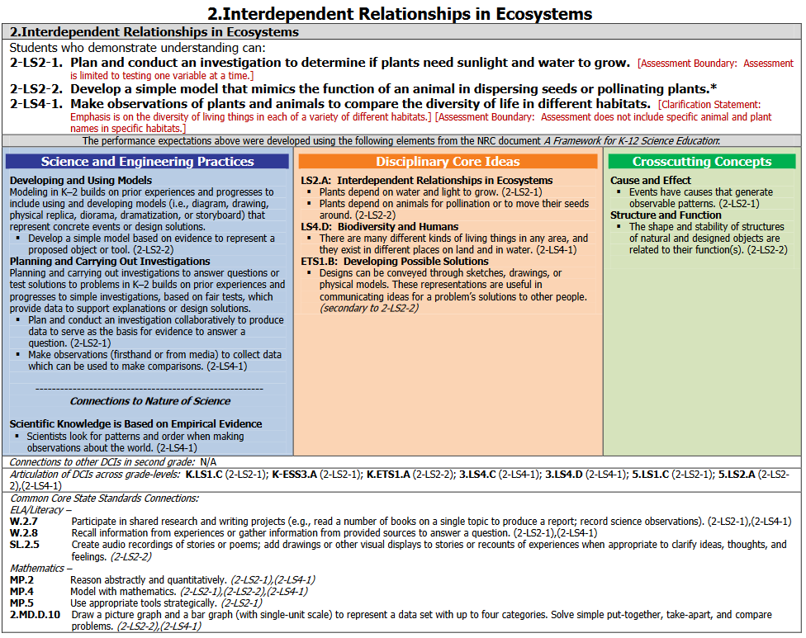

Science in Grade 2 Overview
Science learning for Second Grade students focuses on observations, planning investigations, data collection and analysis for finding patterns of cause and effect and sharing ideas with others.

In this Anchoring Phenomenon Routine, the students will make observations of the plants around their home/neighborhood, draw pictures, make written notes, and look for predictable patterns (similarities and differences) as well as cause and effect. They will identify their own questions about the plants in their yard or neighborhood and add those questions to the KLEWS chart.

As part of the ongoing work, then, students can continue these observations in a variety of areas to identify the patterns of successful growth and plants that may struggle to survive. By observing these patterns, they make the connection to the needs of plants. In making these simple and easily accessible observations of plants and vegetation, students are planning and carrying out investigations about what plants need to grow and survive.

Do plants need the same amount of water and sunlight to grow?
How do plants survive in different areas?
(Sample questions choices)
What do we think we KNOW? | What are we LEARNING? | What is our EVIDENCE? | What are we WONDERING? | What SCIENCE words and principles help us explain?
Example initial KLEWS chart

Materials needed: Each student will need a couple seeds and a way to grow them.

Synchronous Time- 65 minutes

Present a Phenomenon - 5 minutes
Begin by sharing with students your observations of the plants and vegetation in your yard or a local place. In telling your observations include details about the number of different plants, the plants that grow in sunny areas, plants that grow in shaded areas, plants that grow in very dry areas, and plants that grow in wet areas. There may be areas where no plants grow. begin by sharing with students your experiences planting a garden in your yard/pots. See bold text in sample talk below for connections to these words.

Sample Talk: This morning I walked outside to look at the small garden I planted next to my house. I have lots of chipmunks and bunnies by my house, so I put a small fence around my garden. I planted different seeds in my garden - some vegetable seeds and some flower seeds. Sometimes when the soil looks dry, I water my garden with a watering can. I like to look at it everyday to see if anything is growing or if anything in my garden looks different than it did the day before. This morning, I noticed many different things. I noticed that there was a tree above part of my garden and it made a shadow. I saw that some seeds had sprouted and some seeds had not. I noticed that all of my bean seeds had sprouted and were growing into plants. The bean plants were different sizes. . I wondered. I wondered if I watered all of the plants the same way. I also wondered if it made a difference in where I planted the seeds in my small garden.

Begin creating the KLEWS Chart. Share with students the Driving Question at the top of the chart. Share that the class is going to really think about what seeds and plants need to grow.

Notice and Wonder - 15 minutes
Adding to the KLEWS Chart, using the What do we think we KNOW and What are we WONDERING columns

Science Talk Opportunity
Ask students to comment on your story. For example, you could say
Tell us all about an experience you have had growing something in a garden or a pot. What ideas do they have about the garden? hat do they notice about the story, what are they wondering about?

Use the Talk Moves linked above to encourage students to refer to others ideas as they talk. Use revoicing and questions to help students include words such as garden, seeds, sprouting, plants, growing, soil, water and sunlight into their comments. If students do not use these words yet, there will be time to introduce and build on them later.

During this discussion begin to add student’s ideas to the What do we think we KNOW and What are we WONDERING columns. Use these columns flexibly to document students’ ideas.

Potential Student Ideas that might be added to the two columns. In general, students’ noticings and current thinking (without teacher/adult editing) would be added to the KNOW column and student questions could be added to the WONDERING column.

What do we think we KNOW? | What are we WONDERING?
A garden is where we grow flowers and vegetables. | What do we need for a garden? Do flowers and vegetables grow anywhere other than a garden? What about other kinds of plants?
Seeds turn into plants. | What do seeds need to grow?
There are many different kinds of seeds. | Can we tell what a seed will turn into?
Seeds and plants grow in soil. | Do seeds and plants need soil to grow? What is soil?
Plants grow differently. | Why do some plants grow faster, slower, bigger, smaller than others?
Plants have needs, just like us, to grow. | What do plants need to grow and survive?
Plants grow in the sun and the shade. | Do plants need sunlight to grow?
Plants need water. | Do plants need the same amount of water?

Create and Compare Initial Models - 25 minutes
Have students think of a place they can observe plants growing. Observations of plants are better, if students can be outdoors. This does not have to be a garden; most any location where plants/weeds/wild flowers are growing is suitable. The location may be in the yard, at a park, down the sidewalk, in a parking lot. Students will discover that plants grow most everywhere. (Note: Find a location with a diversity of plants and habitats - moist, dry, poor soil, rich soil, etc. - if possible.) Each student should have a science notebook or paper to write down their observations and their questions.

Have students visit the place that they have named and spend 20 minutes documenting the spot, drawing pictures of the plants, paying attention to the different types of plants, their sizes, colors, etc. Encourage the students to make careful drawings of their location and to make sure they can return to it at a later time to make a comparative drawing. (Remind students to not eat anything they find and to not touch plants unless they know for sure what the plant is). It is important that students have a record of their personal nature walk.

As you are making your observations, you may ask yourself the following questions:

What do you notice about the plants?
Are they all the same plants or different plants?
What do you notice about where plants are growing?
Are they in the sun or in the shade? Are they in a garden?
Is there anything unusual about where they are growing?
What do you notice about how the plants are growing?
Are some plants bigger/smaller?
What do you think plants need to grow outside?

At the next class meeting, spend time with students sharing their drawings. They might have added them to an electronic class notebook or they can share using a phone or computer camera.

As students share, ask them some questions to help them identify that different students saw different plants and that many plants look different. Pay special attention to the location of various plants and mention differences in soil, water, sunlight, that students might have represented but do not identify in their summary. Tell me more about the place you observed. Was there a lot of sun there or mostly shade? Do you think that your plants and your location gets a lot of rain and does the ground stay wet all the time or is it pretty dry?

Also important is to help students identify similarities and differences in how they drew their observations. Talk with students to help them identify the variety of ways that plants, the number of plants and the location of plants were represented in the drawings across the group. Point out ways that students used different representations and symbols to show these features of their observations.

Next, lead the drawing of a picture (this will be a Second Grade-level model that describes the phenomenon of the location and their ability to thrive in the various locations) that represents their observations, both visual and written, during their nature walk. As you are creating this initial model, help students identify the differences in the locations where plants are growing (sun, shade, good soil, poor soil) and the types of plants that grow in each location. Talk out loud about how you are documenting what the students are sharing. Take up symbols that the students used in their personal drawings as well as markings, and words and explain why you are using them.

This initial whole-group model is one way that students might represent predictable patterns as well as cause and effect, going forward. This initial, class-created, drawing should be shared with the students electronically or copies could be mailed.

Related Experiences and Knowledge - 10 minutes
Discussion of related experiences might have already happened in a previous discussion, when students discuss various plants they are familiar with - for example, they might have already shared stories of helping their family plant flowers and choosing a place where they will receive the most direct sunlight. While acknowledging students’ experiences, the goal is not to relate or delve deeply into the incredible stories of gardening or nature walks but to continue to focus on predictable patterns over time and location.

Remind students of your story from the introduction to the phenomenon. Discuss how your story might have been the same or different from yesterday or in two weeks. The goal is to start building the idea of patterns as well as cause and effect of plant survival. Alternatively, have students return to their previously observed location and repeat their observations, then ask students to observe the initial whole-group model again and compare it to their observations today and their predictions about next week.

Sample Talk:
I was surprised when I looked at my little garden this morning. Some of the plants have grown a lot, but others have grown very little. I was disappointed that many of the plants looked wilted or shriveled.
I thought it was interesting that even though the plants are growing, they don’t look as healthy as they did a few days ago.

Include time to discuss students’ ideas about what plants need to grow. It is important to discuss that they may have plants in their homes or in their yards that they take care of. Share ideas about how they take care of plants, if appropriate. Talk about our needs as human beings and how our needs are similar or different than plants’ needs. Students may already know that plants need water and sunlight, they do not eat food like humans. Compare their initial drawings (if using the asynchronous option above) to the initial model drawing. Talk about sunlight and water in each of the areas of their models.

Adding to the KLEWS Chart WONDERING Column - 10 minutes
Ask students to share questions they have about plants and plant growth. Previously, students’ questions might have been part of the discussion. Or they may have written down questions during their nature walk. This is a more formal opportunity to generate and document additional student questions. Use the talk moves, to help students ask questions, refer to the questions that are already listed to help generate more. Encourage students to add questions about sunlight, shade, water sources, water needs of plants to the Wondering column. If you notice that any of these ideas are missing from the questions, note that and ask students if they have questions related to that idea.

Add students’ ideas about related phenomenon/other growing events, plants’ locations, watering, sunlight needs to the KNOW or WONDERINGS columns as appropriate.
What do we think we KNOW? | What are we WONDERING?
Plants can grow in a variety of places. | Do plants grow everywhere?
Each type of plant has a specific type of seed. | Why do seeds look so different?
Plants and seeds grow in soil. | Do seeds and plants need soil to grow and survive?
Plants grow differently in different locations. | What are the conditions that are best for plants to grow?
Plants have specific needs to grow. | Are plant needs and human needs the same?
Some plants grow in the sun and some grow in the shade. | Can plants grow in the dark?
Plants need water to grow. | How do plants get their water? How much water do plants need?
 | Do some plants survive better in the shade than the sun?
 | Why is sunlight important to plants?
 | Can plants get too much water?
 | How does a plant get the water it needs to survive?

Investigations
Following the Anchoring Phenomenon Routine, students begin investigations that help them explain whether plants need water and sunlight to grow. They may also answer some of the questions that have been added to the Wondering column. These questions will vary and the investigations might also vary. There are many ways to use the list of potential investigations with at home learning -

- Share the list of potential investigations with adults at home and ask them to support their student in completing one of the investigations.
- As students to select a Wondering that is interesting to them and will help them understand the phenomenon, provide them with the potential investigation.
- Use face-to-face or synchronous meeting times to support one or two class investigations where all students are completing the same investigation in the same way.
- If there are small group or one-to-one check-ins, have students who selected a similar investigation, share their documentation, drawings, models, and describe what they are sharing and their experiences.

The investigations rely on Second Grade observations and models of predictable patterns as well as cause and effect over time. Adults can photograph these models and add them to the class LMS (Learning Management System) electronically. Discussions of the models could also happen over the phone. If you can’t see the students’ models, ask questions about how they represented the sun/moon ideas and listen carefully for documentation and identification of patterns over time.

What are we WONDERING questions connected to Potential Investigations
What are we Wondering? | Potential Investigations
Where do plants grow? | Take outdoor walks to different locations (i.e., backyard, school yard, park, sidewalk, parking lot, etc.). Observe the vegetation in each of the locations. Drawing pictures and taking notes will help when comparing the plants in and among the locations. If an electronic device and internet is available, search for photos of plants around the world.
What do seeds need to grow? | If available, plant a variety of seeds in soil or on a moistened paper towel. Plan an investigation to find out if seeds need soil to grow, if seeds need sunlight to grow, if seeds need warm temperatures, or if seeds need water to grow. Make observations and document using a chart.
What do plants need to grow and survive? | Read multiple stories about plants’ needs. Use the models created by individual students as well as multiple observations to identify what all plants need to grow and reproduce.
Do plants need sunlight to grow? | Investigate whether plants need sunlight to grow. Purchase or obtain at least three of the same plant. Put one in sunlight, one in shade and cover one with something that will not let sunlight reach the plant. Put them in the same location and give the same amount of water. Record observations over several weeks, create a chart/graph. Document with photographs or drawings.
Do plants need water to survive? | Investigate whether plants need water to grow. Purchase or obtain three of the same plant. Place them in the same location. Water one plant daily, water one plant when the soil feels dry and do not water the third plant. Record observations over several weeks; create a chart/graph. Document with photographs or drawings.
How do plants get water? | Obtain a plant that has not been watered and is drooping. After watering the plant, make observations. Document with drawings. Place celery or a flower in colored water. Make observations over several hours. Document with photos or drawings.

In subsequent meetings, have students share their models, graphs and charts; organize them to show predictable patterns as well as cause and effect over time. Discuss patterns that occur in their models.

For example, when the students compare models, they notice that when the plants were in the dark, none of them thrived. When the plants received water every day, the leaves began to yellow or fall off. Likewise, when discussing cause and effect, the plants that received no water or sunlight(cause) did not thrive (effect). The plants that received optimal sunlight and water thrived well.

Example - End of Learning KLEWS Chart
Do plants need water and sunlight to survive? (Sample question)
What do we think we KNOW? | What are we LEARNING? | What is our EVIDENCE? | What are we WONDERING? | What SCIENCE words and principles help us explain?
Plants grow and survive in a variety of places. | Different plants can grow in different locations.  → | We observed plants in the garden, in the field, in the yard, in cracks on the sidewalk, in a tree stump.  → | Is there anyplace that plants cannot grow? | Garden  Needs  Soil  Dirt  Sunlight  Water  Habitat
Seeds have similar but different needs than plants. | Seeds need warmth, (air) and water to grow. Plants need sunlight, water, (air), to grow.  → | We conducted an investigation and planted seeds in soil and on paper towels. We kept them moist. We put some in the light and some in the dark. We put some in the refrigerator. We created a chart and recorded our observations. .  → | Can plants grow without soil?
Plants need sunlight to grow and survive. | Plants need energy from the sun to grow and thrive..  → | We created an investigation comparing plants in the sunlight, the shade and the dark. We recorded our observations on a chart. We made simple drawings or took photographs. .  → | How do plants use sunlight to help them grow?
Plants need water to grow and survive. | Water is important to plants. Without water, a plant will droop. Water carries food throughout the plant.  → | We did an investigation to find out if plants need water to grow. We compared three plants: one that was watered when dry, one watered everyday, and one that was not watered. We recorded our observations on a chart. We documented our investigation with photographs or drawings.  → | Do all plants need the same amount of water?
Plants move water through the stems and leaves. | Plants take in water through their roots (and leaves). Special tubes move the water to all parts of the plant. The water carries the food that the plant needs and helps it stand up.  → | We watered a plant that had drooped and observed it over a few hours. We noticed that the plant began to stand upright. We investigated how water moves through plants by placing celery in colored water. We observed the coloring in the leaves of the plant.  → | Are sunrise and sunset the same all over the world?

References:
KLEWS chart collection at NSTA - - https://my.nsta.org/collection/62205

