Anchoring Phenomenon Routine for
Kindergarten Weather
The Anchoring Phenomenon Routine is the launch to student investigation around the anchoring phenomenon. This phenomenon will be the one that students will describe and explain, using disciplinary core ideas, science and engineering practices and crosscutting concepts in investigations. The Anchoring Phenomenon Routine will encourage thoughtful consideration of the phenomenon, initial models, connections to related phenomenon, discussions about the phenomenon and the creation of the KLEWS chart used for documenting student learning.
In an Anchoring Phenomenon Routine, students:
- ● Are presented with a phenomenon or design problem
- ● Write and discuss what they notice and wonder about from the initial presentation
- ● Create and compare initial models of the phenomenon or problem
- ● Identify related experiences and knowledge that they could draw upon to explain the phenomenon or solve the problem
- ● Construct a KLEWS Chart
- ● Identify potential investigations to answer the questions on the KLEWS Chart, adding the questions to the chart
What is a phenomenon?
In these Anchoring Phenomenon Routine resources, we have selected phenomena that are common for students, related to at least one Performance Expectation but preferably two or more, and can be described/explained using at-home learning.
Phenomena are experiences in the natural (science) or designed (engineering) world that encourage students to explore and explain the world around them. Excellent phenomena demand explanation.
Learn more about qualities of good anchoring phenomenon. The first criteria of anchoring phenomenon used in this brief: A good anchor builds upon everyday or family experiences: who students are, what they do, where they came from. It is important that it is compelling to students from non-dominant communities (e.g., English language learners, students from cultural groups underrepresented in STEM, etc.). We were particularly careful about selecting phenomena connected to everyday or family experiences. This should be a common goal for all anchoring phenomena, in these resources and in all science learning resources.
It is not the role of an anchoring phenomenon to be phenomenal. For example, in this weather learning experience we did not choose a weather event like a thunderstorm or tornado. These events happen but they are not in the everyday or family experiences of all students. Students can look out a window, walk outdoors, and use their senses to observe, describe, and explain, current weather. This makes everyday weather and the changes the students can observe and document, a perfect phenomenon.
PE Focus Bundle at NSTA.org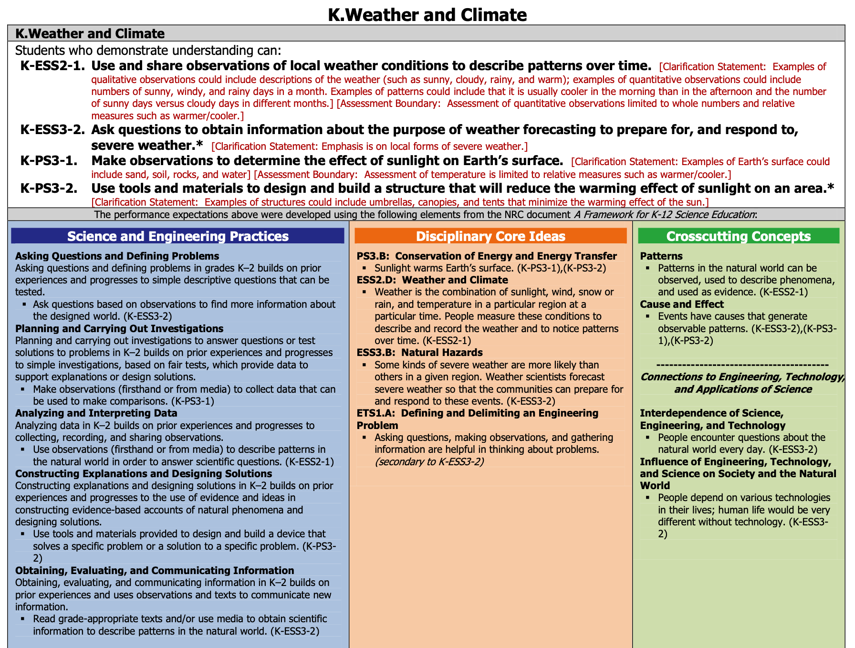

Overview
Science learning for Kindergarten students focuses on observations, data collection and analysis for finding patterns over time, and sharing ideas with others.

In this Anchoring Phenomenon Routine, the students will make observations of the weather, from their home, draw pictures of the weather (creating a model/artifact of their observations), and identify multiple criteria for weather. They will identify their own questions about the weather, focusing on rain/snow, temperature, wind as factors of the weather, and add those questions to the KLEWS chart.

As part of the ongoing work, then, students can continue these observations over multiple days to identify (with support) the patterns in the weather that they can observe. In making these simple and easily accessible observations of weather, students are planning and carrying out investigations.

Is the weather the same every day? (Sample question)
What do we think we KNOW? | What are we LEARNING? | What is our EVIDENCE? | What are we WONDERING? | What SCIENCE words and principles help us explain?
Example initial KLEWS chart

At home needed materials - paper and drawing materials

Synchronous Time- 55 minutes

Asynchronous Time- 25 minutes

Asynchronous Initiation (Optional)

Present a Phenomenon - 5 minutes
Begin by sharing with students your observations of today’s weather. In telling your observations include details about rain/snow, wind, sunlight, clouds, and temperature. See bold text in sample talk below for connections to these words.

Sample Talk: This morning I had to put on a sweater. I didn’t wear a sweater yesterday but today it seems cooler than yesterday. I like the cooler weather so I was happy to wear my favorite sweater. As I was getting ready for you today, I noticed that the sky was cloudy, I couldn’t see the sun even though it was light outside. I’m not sure if it is going to rain or not but there are a lot of white clouds outside my house and the wind is blowing.

Begin creating the KLEWS Chart. Share with students the Driving Question at the top of the chart. Share that the class is going to really think about the weather and how it changes from day to day.

Notice and Wonder - 15 minutes
Adding to the KLEWS Chart, using the What do we think we KNOW and What are we WONDERING columns

Science Talk Opportunity
Ask students to comment on your story. What ideas do they have about the weather, what do they notice about the story, what are they wondering about? They might also share their own weather stories. Use the Talk Moves linked above to encourage students to refer to others ideas as they talk. Use revoicing and questions to help students include temperature, wind, rain/snow, clouds, etc into their comments.

During this discussion begin to add students ideas to the What do we think we KNOW and What are we WONDERING columns. Use these columns flexibly to document students’ ideas.

Potential Student Ideas that might be added to the two columns. In general, students’ noticings and current thinking (without teacher/adult editing) would be added to the KNOW column and student questions could be added to the WONDERING column.

What do we think we KNOW? | What are we WONDERING?
It only rains when there are clouds | Where is the sun when it is cloudy?
Yesterday the temperature was warmer/higher | What makes the temperature change?
Even when there are clouds the sun is behind them. | Why are there clouds? What makes clouds happen?
The sun makes the temperature go up | Why does the wind blow the trees?
Wind makes the trees move and makes me cold when I am outside. | Does the wind blow the clouds too?
Potential student Responses for KLEWS columns

Create and Compare Initial Models - 15 minutes
Have students find a place they can observe the weather of the day. They can look out a window or step outside. Observations of the weather of the day.

When students’ return with their observations - lead the drawing of a picture (this will be a Kindergarten-level model that describes the phenomenon of weather) that represents the weather as students describe it. As you are creating this initial model, help students identify the sky (clouds/sun), rain/snow/none, temperature, wind, and include these in your drawing. Share with students and ask for their input on how to represent the features of the model that are required. Talk out loud about how you are documenting what the students are sharing. Clarify with students and identify any symbols, markings, words that you use and explain why you are using them.

This initial exemplar is one way that students might represent the weather going forward. This initial, class-created, drawing should be shared with the students electronically or copies could be mailed.

Related Experiences and Knowledge - 10 minutes
Discussion of related experiences might have already happened in a previous discussion, when students discuss various weather stories - for example, they might have already shared stories of rain storms, differences in wind, etc. While acknowledging students’ experiences, not to delve deeply into the incredible stories of weather but to continue to focus on weather patterns over time.

Remind students of your story from the introduction to the phenomenon. Discuss how your story might have been the same or different from yesterday. The goal is to start building the idea of patterns and/or weather changing. Alternatively, ask students to observe the initial model again and compare it to previous weather or the weather of the day. However you are able, the goal is to help students observe day over day changes in the weather.

Sample Talk:
I was surprised that I had to grab a sweater today because yesterday I wore shorts and a t-shirt.
I thought it was interesting that I had to get my umbrella/raincoat again today. That is the third day in a row that I have used my raincoat.

Include time to discuss students’ ideas about how the weather has changed over the last few days. Compare their initial drawings (if using the asynchronous option above) to the initial model drawing.

Adding to the KLEWS Chart WONDERING Column - 10 minutes
Ask students to share questions they have about the weather. Previously, students’ questions might have been part of the discussion. This is a more formal opportunity to generate and document additional student questions. Use the talk moves, to help students ask questions, refer to the questions that are already listed to help generate more. Encourage students to add questions about rain/snow, wind, temperature, clouds, to the Wondering column. If you notice that any of these weather ideas are missing from the questions, note that and ask students if they have questions related to that idea.

Sample Talk:
When I read through (read the questions again) all the questions you have shared here, I notice that we haven’t asked any questions about (clouds, wind, temperature, rain/snow). We drew our model and we included (insert the weather idea here) by drawing and labeling. So, it seems like it would be important to add questions about it to the Wondering column. What questions do you have about that idea?

Add students’ ideas about related phenomenon/other weather events, to the KNOW or WONDERINGS columns as appropriate.
What do we think we KNOW? | What are we WONDERING?
It only rains when there are clouds | Where is the sun when it is cloudy?
Yesterday the temperature was warmer/higher | What makes the temperature change?
Even when there are clouds the sun is behind them. | Why are there clouds?
The sun makes the temperature go up | Why does the wind blow the trees? Does the wind blow the clouds too?
Wind makes the trees move and makes me cold when I am outside. | How does the weather change over time?
 | Why does the temperature go up and down?
 | When does it rain? When does it snow?
 | What makes clouds happen?
Potential student Responses for KLEWS columns

Investigations
Following the Anchoring Phenomenon Routine, students begin investigations that help them explain weather and answer some of the questions that have been added to the Wondering column. These questions will vary and the investigations might also vary. There are many ways to use the list of potential investigations with at home learning -

- Share the list of potential investigations with adults at home and ask them to support their student in completing one of the investigations.
- As students to select a Wondering that is interesting to them, provide them with the potential investigation.
- Use face-to-face or synchronous meeting times to support one or two class investigations where all students are completing the same investigation in the same way.
- If there are small group or one-to-one check-ins, have students who selected a similar investigation, share their documentation, drawings, models, and describe what they are sharing and their experiences.

The investigations rely on Kindergarten models over time. Adults can photograph these models and add them to the class Learning Management System electronically. Discussions of the models could also happen over the phone. If you can’t see the students’ models, ask questions about how they represented the weather ideas and listen carefully for documentation and identification of patterns over time.

What are we WONDERING questions connected to Potential Investigations
What are we Wondering? | Potential Investigations
Why are there clouds? | Draw the clouds every day and compare to the wind and/or temperature and/or rain/snow  Support learning by reading weather books.
When does it rain? When does it snow? | Draw the clouds when it is going to rain
How does the weather change over time? | Using a grid, document the weather for five days straight. Look for patterns
Where is the sun when it is cloudy? | Students draw similar pictures of the weather on several different days. Remind students to include details and labels as shown in the initial model.
What makes the temperature change? | Measure temperature on a surface over time and note whether it is sunny or cloudy.
Why are there clouds? | Observe the sky, what for changes when there are cloudy times or sunny times. Read books about clouds and what makes clouds.
How does the weather change over time? | Look at maps, create maps, over time. Watch for how changes in the weather might be seen over time.
When does it rain? When does it snow? | Look at temperatures on snowy days and compare to rainy days. Use the computer to find snowy days in December and January and compare to days in April and May.
Potential student Responses for KLEWS columns

In subsequent face to face meetings, have students share their models, organize them by day to show changes in weather over time. Discuss patterns that occur in their models. For example, notice that rain/snow only happens when there are clouds, temperature changes often happen before and after rain or snow, wind also often precedes or follows weather changes. In face to face meetings it would also be appropriate to share with students weather maps and the ways professionals document the weather.

Example - End of Learning KLEWS Chart
Is the weather the same every day? (Sample question)
What do we think we KNOW? | What are we LEARNING? | What is our EVIDENCE? | What are we WONDERING? | What SCIENCE words and principles help us explain?
It only rains when there are clouds | Even when the sky is cloudy, in the daytime, the sun is behind the clouds.  → | We read about the sun and cloudy days. Every book says the sun is still there on cloudy days.  → | Where is the sun when it is cloudy? | Cloudy  Clouds  Warm  Cool  Warmer  cooler  temperature  Blow  move  Time  pattern  weather
Yesterday the temperature was warmer/higher | When the sun is bright things outside get a lot warmer. On cloudy days, things are cooler  → | We took the temperature of things outside in the afternoon on cloudy and sunny days and saw a pattern.  → | What makes the temperature change?
Even when there are clouds the sun is behind them. | Clouds are created when there is water in the air. They can also show that there is going to be a change in the weather.  → | We observed that there are clouds when it is going to rain or when the rain is going to happen the next day. We read about how clouds are made.  → | Why are there clouds?
The sun makes the temperature go up | The wind is moving air and the wind can move the tree leaves when it is blowing. It can also move the branches in a windstorm.  The wind blows the clouds too. There is wind high in the sky and it makes the clouds move.  → | Over the course of two weeks we observed the weather. Most of the time the leaves were not moving or moving very little. When there was wind and we could feel the wind on our skin, the leaves also moved. When the wind blows harder, different parts of the tree move. The harder the wind, the heavier parts of the tree moved. On really stormy days, the wind moves the tree branches and the wind moved the clouds very fast.  → | Why does the wind blow the trees? Does the wind blow the clouds too?
Wind makes the trees move and makes me cold when I am outside. | Weather moves across the sky. Mostly from west to east. Different temperatures and wind change the weather.  → | We looked at a bunch of weather maps for several days. We noticed a lot of changes in the weather. We could tell what kind of weather we were going to have the next day by looking at the maps.  → | How does the weather change over time?
 | There are a lot of reasons for the temperature to change but an important one is the sun. All temperature changes are caused by the sun.  → | We measured temperature changes on stuff, we read a lot of books, we watched maps. We noticed that the temperature changes the most on sunny days. We think this means that the sun is an important part of temperature changes.  → | Why does the temperature go up and down?
 | When the temperature is warm, it rains. When the temperature is cold, it snows. Snow happens in the winter and rain in the spring and summer.  → | We looked at data from snowy days in December and January and rainy days in April and May. We noticed that the temperature is always cold when it snows and warm when it rains.  → | When does it rain? When does it snow?
 | The water in the air and the temperature of the air make clouds. The more water the more clouds there are.  → | We read several books and looked for information about how clouds are made.  → | What makes clouds happen?
Potential student Responses for KLEWS columns

References:
KLEWS chart collection at NSTA - - https://my.nsta.org/collection/62205

